Releasable: NbsW.exe
Watcher executable that watches the SMS Sockets for SMS messages and saves them in the mail store. It starts up when the OS starts (this is the responsiblility of the DFRD to put it in the startup sequence).

Class CNbsWatcher:
(Nbs = Narrow Band Sockets - SMS Smart messages identified by string patterns like //MLAP)

Files: BioMsg/BioWatcher/(inc|src)/NbsWatcher

Description:
This is the basis of the NbsWatcher Exe (NbsW.exe). It is a container that manages a list of CNbsSocketWatcher Active Objects which wait for NBS messages.

When it starts, it collects a list of NBS Patterns it should watch, creates a CNbsSocketWatcher Active Object for each one and fires them off to watch the SMS patterned sockets. See CNbsWatcher ::ConstructL().

It will always be running when EPOC is running. If it stops, messages will be left on the device until the CNbsWatcher is started again.

Class:

CNbsWatcher : public Cbase

CArrayPtrFlat<CNbsSmsSocketWatcher>* iSocketWatchers

Testing:

WINS
T_NBSWatcher: This test harness will run in the windows wmulator - creating a CNbsWatcher which is actually a ‘dll’ in WINS. The test harness will start up the app which will then do all it’s stuff to watch the SMS ports with the registered patterns.

ROM: When compiled with Debug turned on - the states of the exe are reported to the console.

Notes: The number of NBS watchers are determined by registered patterns which are stored in Bif files that live in (*)\system\data\*.bif. CBioDB is the class that collects and returns the requested bearer (EBioMsgIdNbs).

Class: CBaseSmsActiveSocketWatcher

Files: BioMsg/BioWatcher/(inc|src)/SmsSocketWatcher

Description:
This is an Abstract Base class for an Active Object Socket watcher. Each Socket Watcher binds to a specific port, goes into a Wait state - waiting for a message to arrive, changes to the Read state to read and/or process the message, then put itself back in the Wait state for the next message to arrive.

CBaseSmsActiveSocketWatcher::DoRunL()

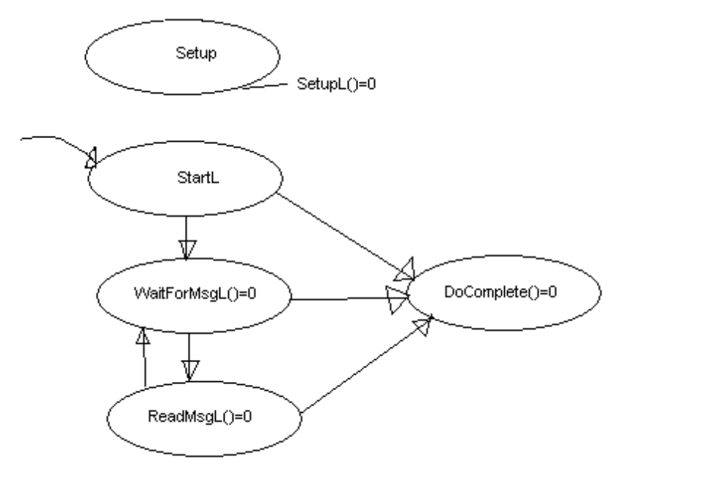

Currently there are two users of this base class both SMS watchers. The NBS Socket watcher that watches for patterns and the Wap Socket watcher that watches.

A utility function to save the message into the EPOC mail store is included in the base class as it is assumed all SMS watchers will store the message in the same way.
CBaseSmsActiveSocketWatcher::StoreMsgL(CSmsMessage* aSmsMsg)

Class:

CBaseSmsActiveSocketWatcher : public CActive

virtual void DoSetupL() = 0;
void StartL();
virtual void WaitForMessageL() = 0;
virtual void ReceiveL() = 0;
void StoreMsgL(CSmsMessage* aSmsMsg);

Testing:

The #define __FILEWATCHER__ is designed for testing the object without using any Rsockets. Instead of reading in input from an RSocket - it will look in c\biotest\fresh for files and try to match itself (rather than letting the SMS stack to the work). If it does match, it will read it up and store it in the mail store, move the file out into the c\biotest\stale directory. Because of the nature of the Watcher, which is an exe, the test code is put in directly here - but is not compiled in when testing with the SMS stack.

All __FILEWATCHER__ is test code and will not be in production code - where __FILEWATCHER__ in not defined. The real case is actually much simpler.

Class: CNbsSmsSocketWatcher : public CBaseSmsActiveSocketWatcher
Files: BioMsg/BioWatcher/(inc|src)/ NbsSocketWatcher

Description:
This is a concrete Nbs SMS Active Object Socket watcher. Each Socket Watcher binds to a specific port by passing in a String pattern (like //MLAP) that is passed in as part of the constructor.

The following functions are implemented
CNbsSmsSocketWatcher ::DoSetupL() - creates & binds to an RSocket
CNbsSmsSocketWatcher :: WaitForMessageL - asynchrounsous wait for a message to arrive
CNbsSmsSocketWatcher :: ReceiveL() - handles the message

Testing:

The #define __FILEWATCHER__ is designed for testing the object without using any Rsockets. Instead of reading in input from an RSocket - it will look in c\biotest\fresh for files and try to match itself (rather than letting the SMS stack to the work). If it does match, it will read it up and store it in the mail store, move the file out into the c\biotest\stale directory. Because of the nature of the Watcher, which is an exe, the test code is put in directly here - but is not compiled in when testing with the SMS stack.

All __FILEWATCHER__ is test code and will not be in production code - where __FILEWATCHER__ in not defined. The real case is actually much simpler.

